Date: 01.08.2025
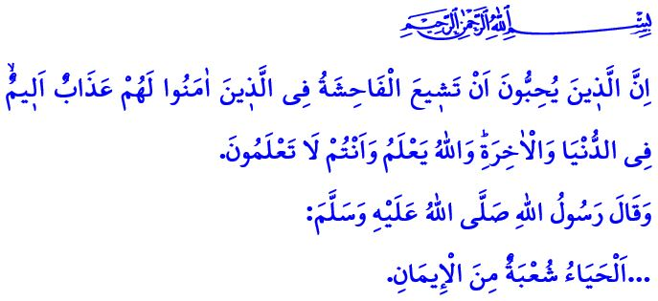MODESTY: A COMMAND OF ALLAH, A REQUIREMENT OF HUMAN NATURE
Honorable Muslims!
One day, the Prophet Muhammad (saw) said to his companions: اِسْتَحْيُوا مِنَ اللّٰهِ حَقَّ الْحَيَاءِ “Have modesty before Allah as is His due!” When the noble Companions said, “O Messenger of Allah! We do indeed feel modesty before Allah,” the beloved Prophet Muhammad (saw) gave them the following reminder: “…To have true modesty before Allah is to protect all the limbs from every kind of sin and haram. It is not to be deceived by the temporary pleasures of this world. It is never to forget death and the reckoning.”
Dear Believers!
Modesty (haya’) is a fundamental moral principle that our sublime religion, Islam, commands for every Muslim, both men and women. It is a dignified stance shown against all forms of excesses of the nafs. Modesty is a powerful shield that protects a person from all evils. It is a way of life— an essential aspect of fitrah (natural disposition), an adornment of the body, and a reflection of faith in one’s life. In the hadith I recited at the beginning of my khutbah, the Messenger of Allah (saw) said: اَلْحَيَاءُ شُعْبَةٌ مِنَ الْإِيمَانِ “…Modesty is a branch of faith.” With this statement, he emphasized the importance of modesty.
Immodesty, on the other hand, is a disaster that destroys moral values and tramples upon a person’s honor and dignity. It is one of the most insidious traps of Satan. Indeed, Allah the Almighty warns us: “O children of Adam! Do not let Satan deceive you as he tempted your parents out of Paradise and caused their cover to be removed in order to expose their nakedness…”
Esteemed Muslims!
Unfortunately, we are living in an age in which privacy is recklessly violated. Today, the clothing industry, fashion designers, and certain media circles promote nudity under the guise of “freedom” and “modernity,” while devaluing modest dress. This mindset reduces both women and men from being honored beings to mere objects that are watched and consumed. Yet, for a person to expose their body, their privacy, and their intimate self before society is a corruption of reason, conscience, and fitrah. The Noble Messenger (saw) said: “Allah, the Almighty and the Majestic, is Forbearing, Modest, and the Concealer of faults. He loves modesty and covering.” Therefore, wearing short or transparent clothing, regardless of place or purpose, is a violation of Allah’s command regarding modest dress and is haram. As the Messenger of Allah (saw) described, those who wear tight clothing that outlines their body are: كَاسِيَاتٌ عَارِيَاتٌ “Naked in spite of their being dressed.” Therefore, let us teach our children the importance of modesty and decency from an early age. Let us raise them by instilling a love for a style of dress that aligns with our faith and our civilization. We must strive to protect our children from anything that may corrupt their fitrah. Neglecting this matter is a serious mistake, a grave irresponsibility, and a heavy burden of accountability for parents.
Dear Believers!
Altering the structure of one’s body through cosmetic surgeries, without any medical necessity, merely for the sake of admiration or imitation is a distortion of the fitrah. It is a form of discontent with what Allah has created and falling into the deception of Satan and is a sin. Indeed, when Satan was cast out from the presence of Allah, he declared: وَلَاٰمُرَنَّهُمْ فَلَيُغَيِّرُنَّ خَلْقَ اللّٰهِۜ “…I will order them […] to alter Allah’s creation…” Moreover, getting a tattoo, regardless of the purpose, is, according to the words of the Prophet Muhammad (saw), a means of being deprived of Allah’s mercy and is haram. Sharing content on screens, digital platforms, and in visual or written media while wearing clothing that is not approved by our religion is an inappropriate act from every perspective and is also haram. In the noble verse I recited at the beginning of my khutbah, Allah the Almighty says: “Indeed, those who love to see indecency spread among the believers will suffer a painful punishment in this life and the Hereafter. Allah knows and you do not know.”
Dear Believers!
The responsibility that Allah has placed upon both men and women regarding modesty and chastity is the same. Indeed, in verses 30 and 31 of Surah al-Nur, Allah the Almighty says: “˹O Prophet!˺ Tell the believing men to lower their gaze and guard their chastity…” “And tell the believing women to lower their gaze and guard their chastity, and not to reveal their adornments except what normally appears. Let them draw their veils over their chests…” Therefore, just as in every aspect of our lives, our standard in matters of clothing and privacy must be the commands of Allah and the Sunnah of the Prophet Muhammad (saw). Let us not forget: garments that expose the body and clothing that reveal bodily contours are not matters of style or image; they are violations of Allah’s commandments. The nudity that is attempted to be normalized through certain films, television series, digital platforms, and advertisements is not courage or freedom; it is an assault on the institution of family. Appearing in public spaces, especially in institutional or formal settings, with inappropriate attire is a challenge even to the most basic standards of morality. This is not modernity; it is primitiveness. Everyone who remains silent in the face of the violation of moral and decency standards bears a heavy responsibility. For safeguarding the chastity, decency, and morality of our youth is a shared duty upon all of us.

I conclude this week’s khutbah with the following supplication of the Messenger of Allah (saw): اَللَّهُمَّ إِنِّى أَسْأَلُكَ الْهُدَى وَالتُّقَى وَالْعَفَافَ وَالْغِنَى “O Allah! I ask You for guidance, piety, chastity, and contentment of the heart.”

Tirmidhi, Sifat al-Qiyamah, 24.
Muslim, Iman, 57.
A’raf, 7/27.
Nasa’i, Ghusl, 7.
Muslim, Jannah, 52.
Nisa, 4/119.
Nur, 24/19.
Nur, 24/30-31.
Muslim, Dhikr, 72. General Directorate of Religious Services

